**Computer Network Lab**

Name: Harshavardhan Anil Bamane

Class: SY BTech CSE

PRN: 22510112

Batch: S-7

Configuration of IPv4 Address using Packet Tracer and Subnetting a network

**Configuring IPv4 Interfaces =>**

1) Designing Actual Topology:

- Place the logical components i.e. two routers R1 and R2, a switch S1 and an end device PC0.

- Use HWIC-2T a High-Speed WAN Interface Card providing two ports for both the routers.

- Connect R2 and S1 through GigabitEthernet Interface, S1 and PC0 through FastEthernet Interface and R1 and R2 through interface Serial0/0/0 using Serial DCE

2) Dividing Topology into Two Networks:

- Divide topology into two networks with network address 10.1.1.0/24 and 172.16.1.0/30 respectively

3) Configuring Devices:

- Assign IP Address (10.1.1.10), Subnet Mask (255.255.255.0) and Default Gateway 10.1.1.1 which will be for interface corresponding to GigabitEthernet

- Access the CLI in R2, go to global configuration mode using configure terminal command and set IP Address and Subnet Mask for interface GigabitEthernet 0/0 as 10.1.1.1 and 255.255.255.0 respectively. Save the configuration.

- Change the state of GigabitEthernet 0/0 to up using no shutdown command.

- Verify by pinging from PC0 to its default gateway and checking for reply

4) Configuring IPv4 Address for Serial Interfaces:

- In R2 configure interface Serial 0/0/0 by giving IP Address 172.16.1.1 and Subnet Mask 255.255.255.252 and change its state to up.

- In R1 configure interface Serial 0/0/0 by giving IP Address 172.16.1.2 abd Subnet Mask 255.255.255.252 and change its state to up.

- Save the configuration on both the routers.

- Verify connectivity between R1 and R2 by pinging from R2 to Serial Interface of R1

**Subnetting a Class C Network =>**

1) Designing Subnetting Scheme:

- Given Network Address is = 192.168.10.0 and Subnet Mask is /25. So here 21 = 2 Subnets are possible and 27 = 128 hosts are possible in each subnet including network and broadcast address.

2) Configuring Devices:

- Assign IP Address as 192.168.10.1; 192.168.10.2; 192.168.10.3, Subnet Mask as 255.255.255.128 and default gateway as 192.168.10.4 for PC0, PC1 and PC2 respectively.

- Assign IP Address as 192.168.10.129; 192.168.10.130; 192.168.10.131, Subnet Mask as 255.255.255.128 and default gateway as 192.168.10.132 for PC3, PC4 and PC5 respectively.

3) Configuring Router:

- Configure interfaces GigabitEthernet 0/0 and 0/1 by giving them IP Address as 192.168.10.4 and 192.168.10.132 respetively and also set the Subnet Mask.

4) Verifying Subnet:

- Verify connection by pinging device of other subnet from device of one subnet.

**Subnetting an IPv4 Network =>**

Here we need LAN – A network with minimum 50 host IP Address, LAN – B with minimum 40 host IP Address and two more additional unused subnets for future expansion.

Network Address is = 198.162.0.0./24

1) Creating a Subnetting Scheme:

- 50 host address are needed in largest required subnet and minimum 4 networks are required considering given conditions.

- For /26 we get 22 = 4 subnets and 26 = 64 hosts – 2 = 62 hosts per subnet

So subnets will be like

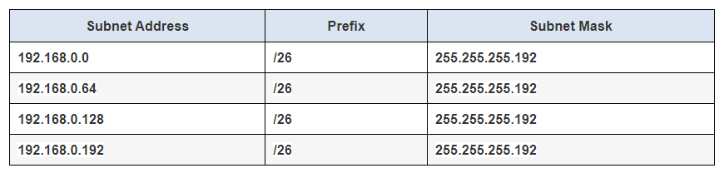

2) Creating an Addressing Table:

- Assign first subnet to LAN – A where use first host address for interface of CustomerRouter which is connected to switch, second host address for LAN switch and last host address for PC – A

- Similarly do for second subnet and LAN – B

Addressing Table will be like

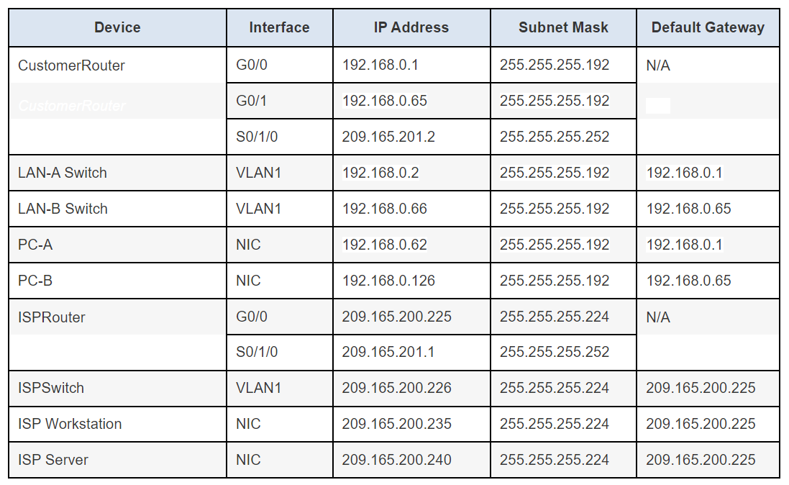

3) Configuring Devices:

- Set secret password on CustomerRouter configure its GigabitEthernte Interfaces 0/0 and 0/1 assign IP address, subnet mask and state their state to up using no shutdown command.

- Configure two VLAN interfaces on two customer LAN switches and configure default gateway for each.

- Configure IP Address, Subnet Mask and Default Gateway for PA – A and PC – B

4) Test the network:

- Determine if both PC – A and PC – B can communicate with their default gateway and with each other with the help of ping command.